AWS CLOUD PRACTITIONER

REGION AND AVAILABILITY ZONES

* Regions are located all over the world.
* Each region comprises of one or more Availability zones.
* When one availability zone is not available next available availability zone can be used..[Advantage]

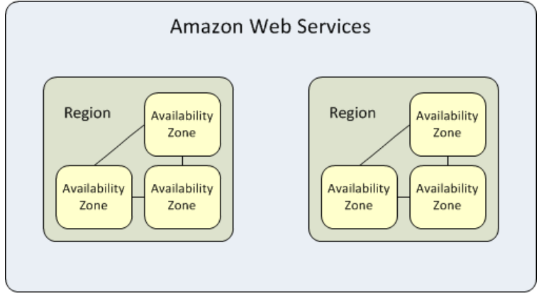

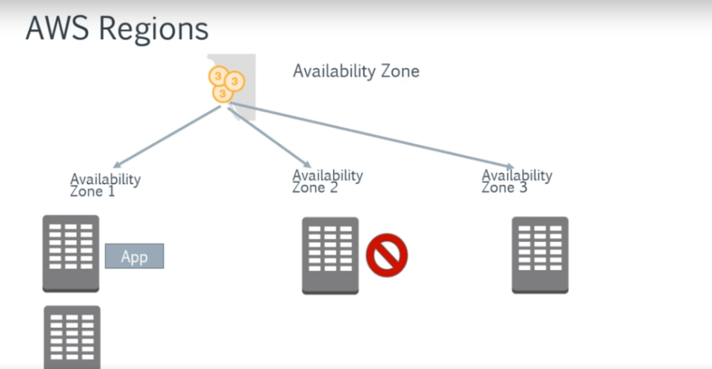



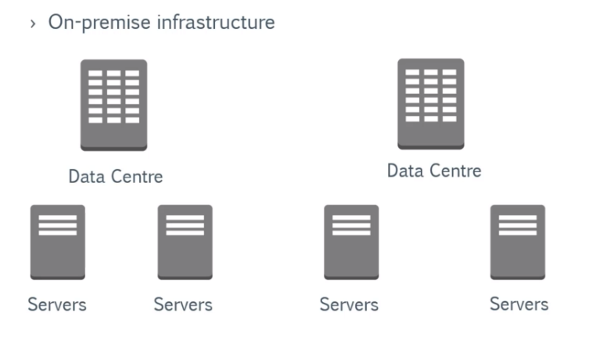

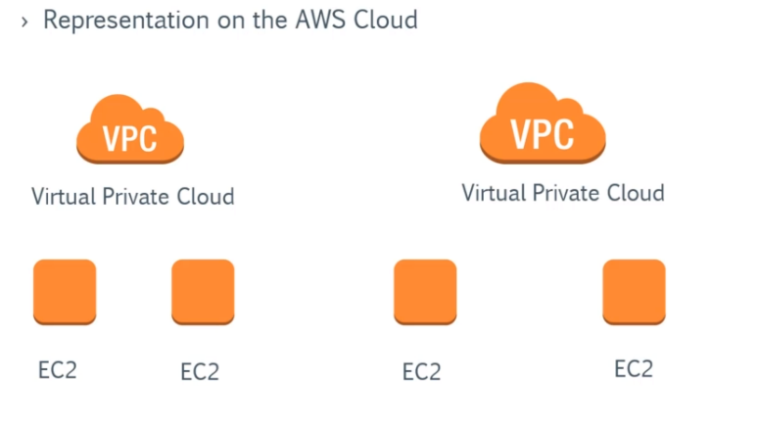

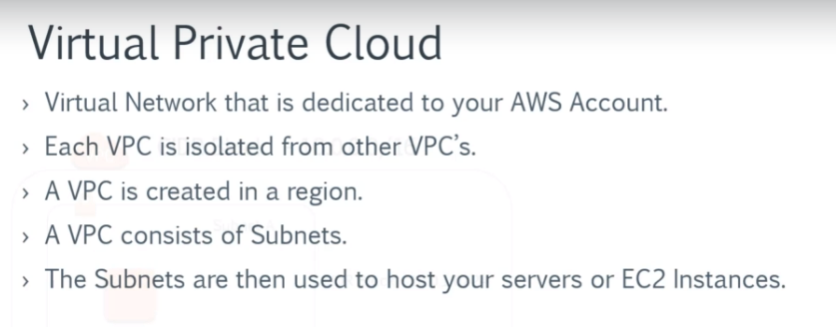

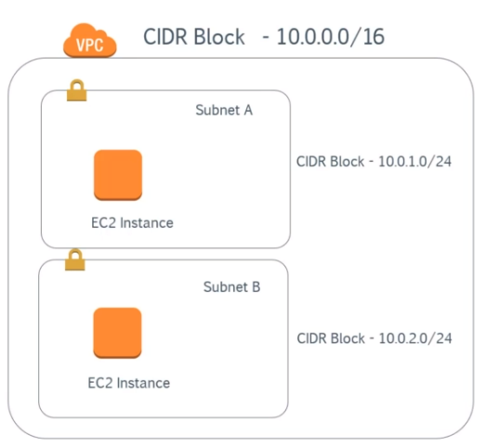

Creating a VPC

In VPC dashboard

Service Health shows the current status and the details of the VPC and the EC2 instances .

It is useful if your trying to find fault it may be also because of the underlying hardware at that time this comes handy.

When an aws account is created an default VPC is created in all regions automatically.

Subnets will be created for each availability zone in that region by default automatically



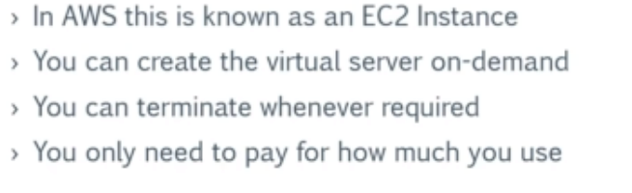

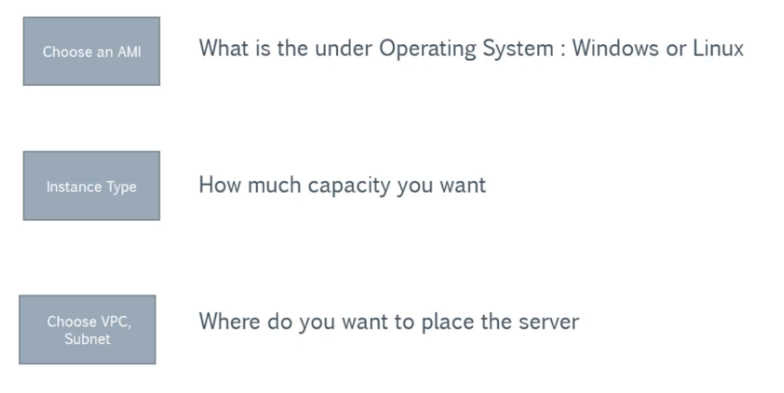

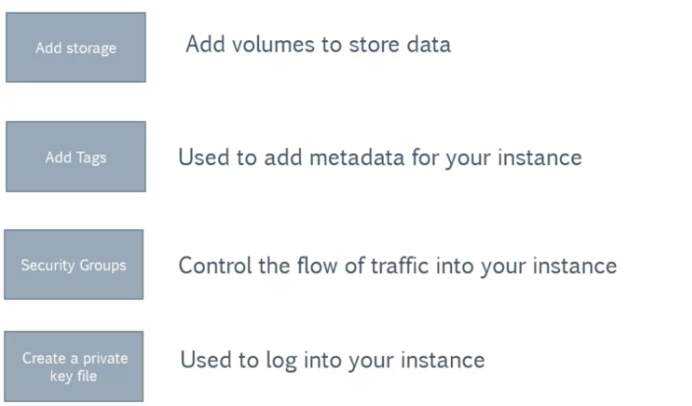

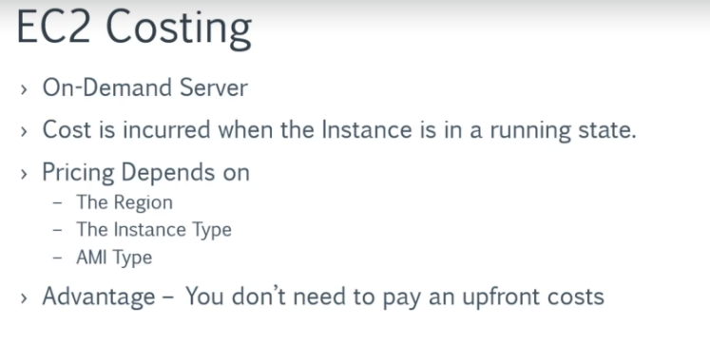

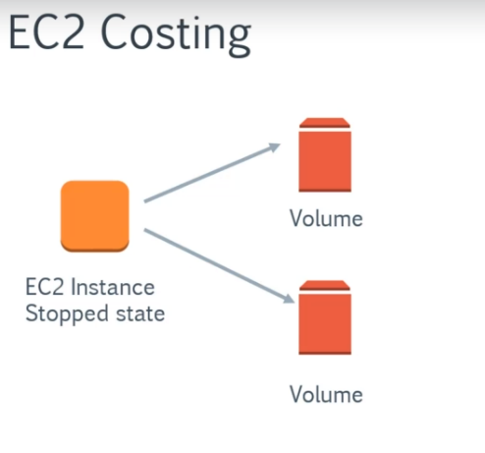

Even when the EC2 instance is in stopped state the costing will be incurred for the volume attached to it as it is a different entity all together.

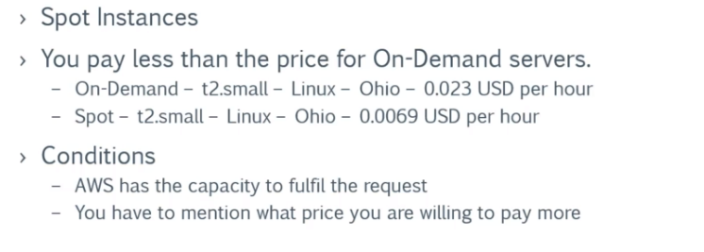

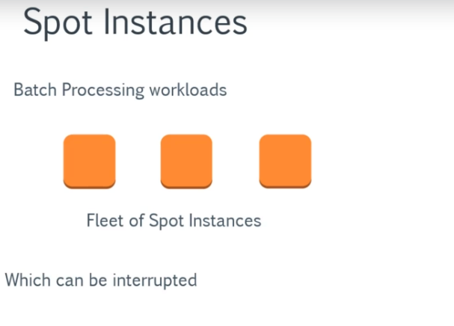

Works that can be interrupted by the aws based on the conditions specified

Aws do not have the capacity to provide the spot instance

Or the amount you pay for the spot instance is less than that of the amount of spot instance at that time.

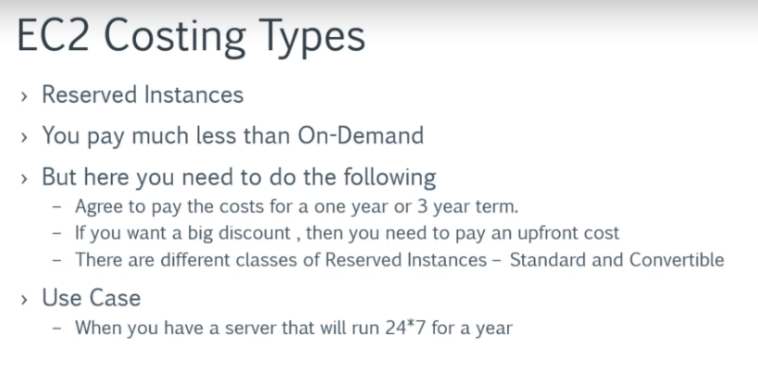



EBS is Elastic Block Storage

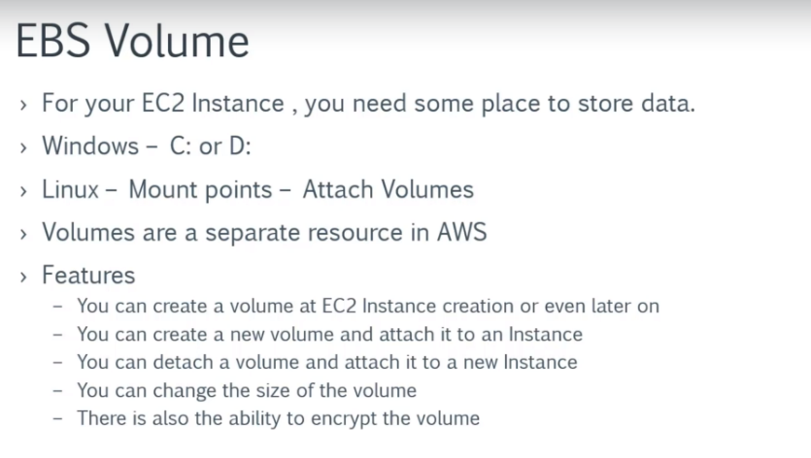

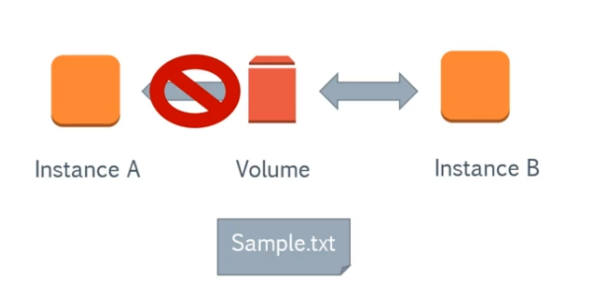

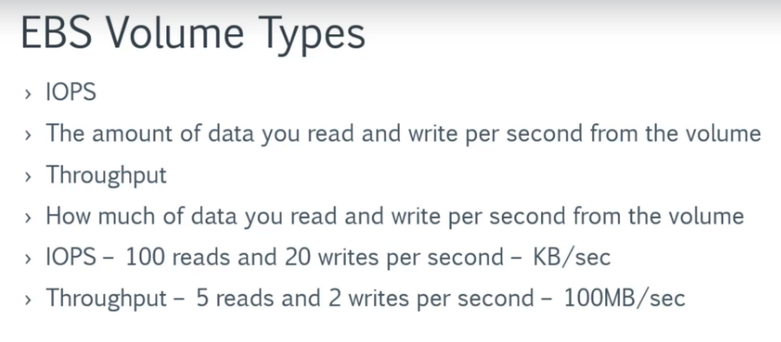

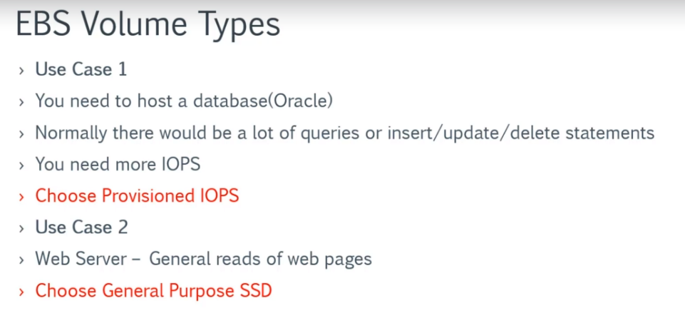

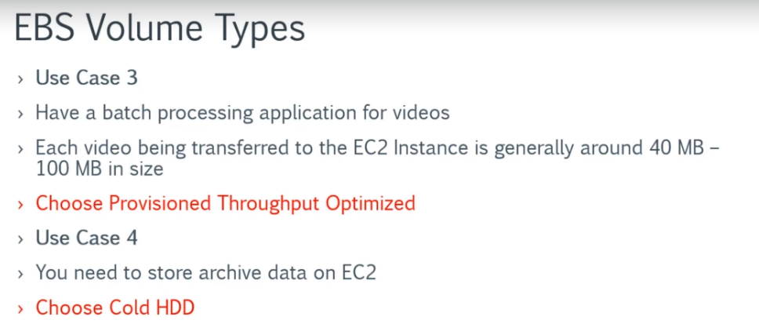



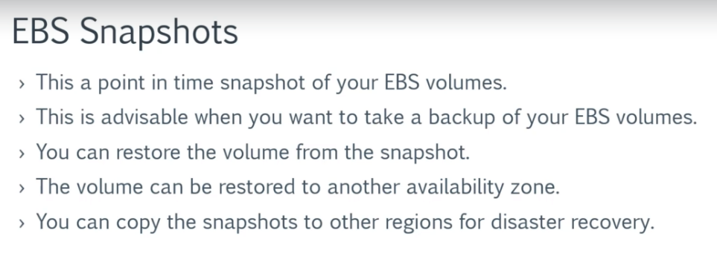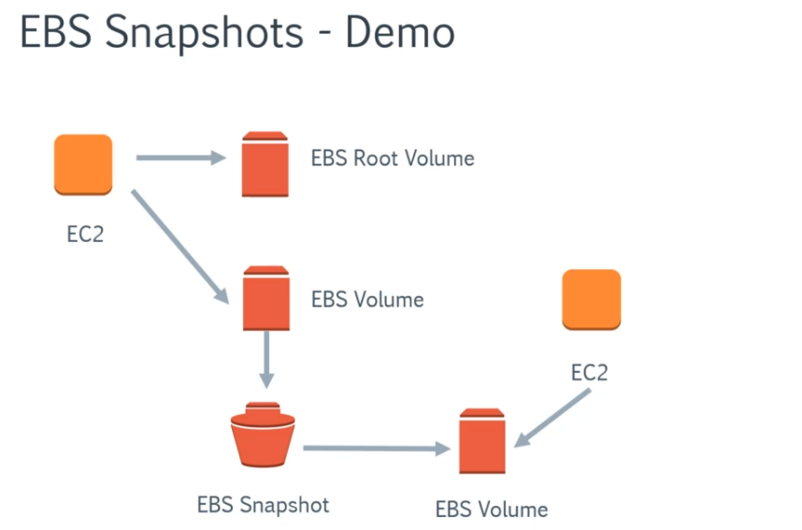

Once the volume is created it will be in available state. It must be attached to an instance.

The instance and the volume must be in same availability zone.

After attaching the volume status will change to in-use.

Creating snapshot

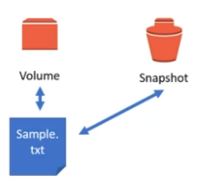

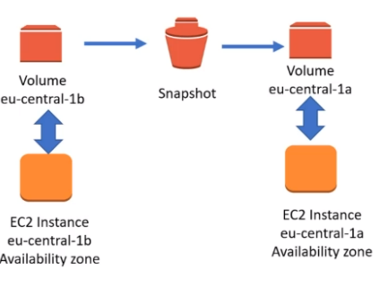



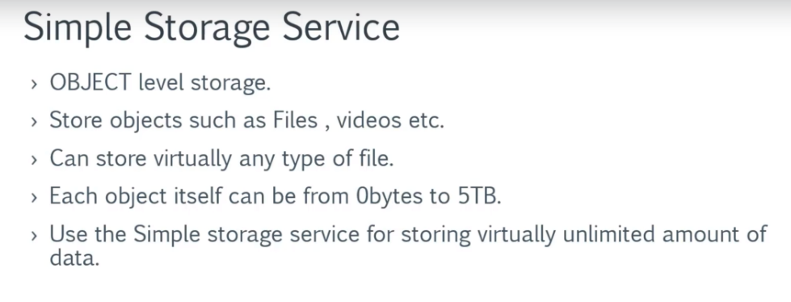

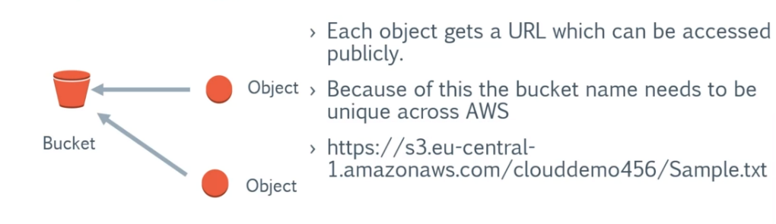

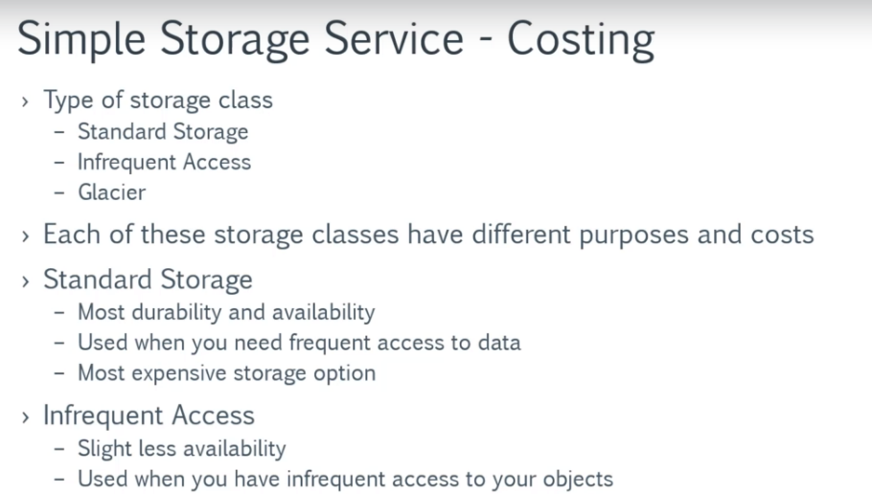

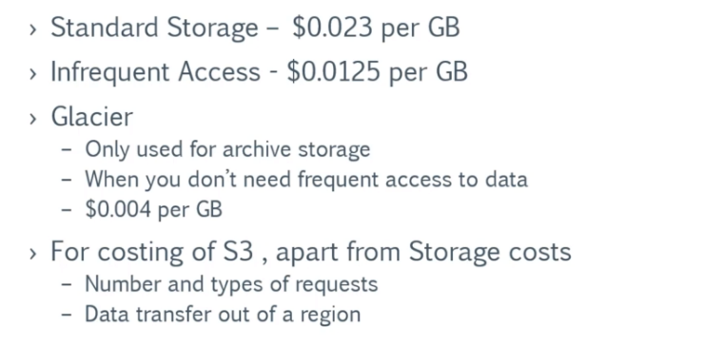

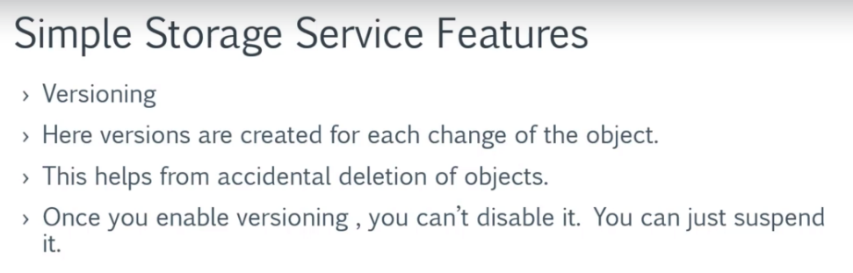

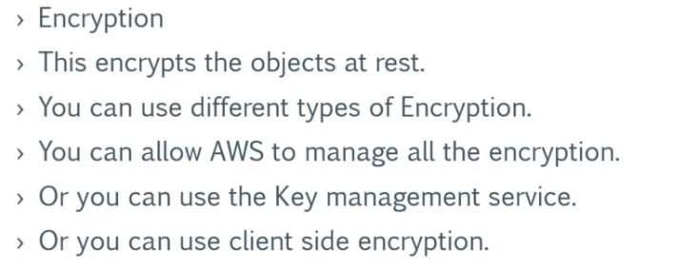

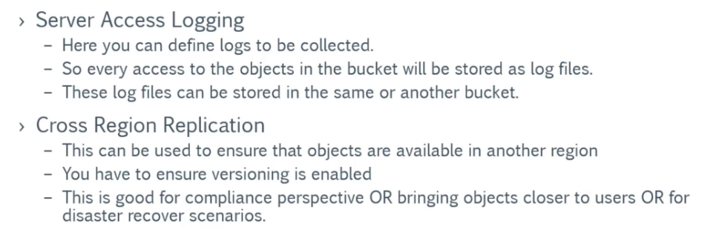

Bucket can be also use to host a static webpage .

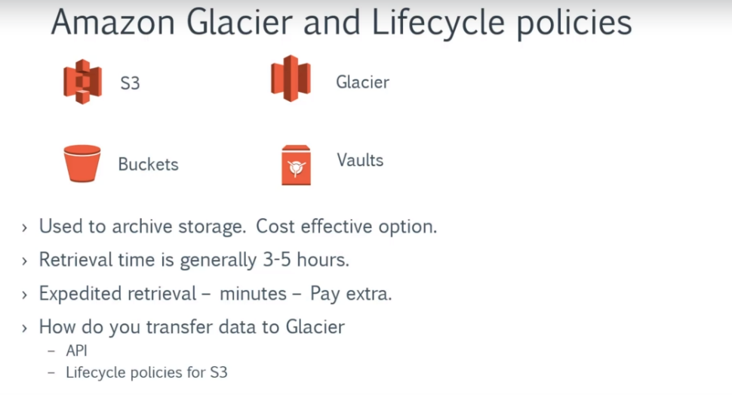

Moving to the amazon glacier can be done in setting the lifecycle policies of the bucket from management ->lifecycles from s3 dash.



Databases currently supported by aws are

Oracle

MySQL

Microsost SQL Server

PostGre SQL

MariaDB

Amazon Aurora is a MySQL and PostgreSQL-compatible relational database built for the cloud

Amazon Aurora is up to five times faster than standard MySQL databases and three times faster than standard PostgreSQL databases

Amazon Aurora features a distributed, fault-tolerant, self-healing storage system that auto-scales up to 64TB per database instance. It delivers high performance and availability with up to 15 low-latency read replicas, point-in-time recovery, continuous backup to Amazon S3, and replication across three Availability Zones (AZs).

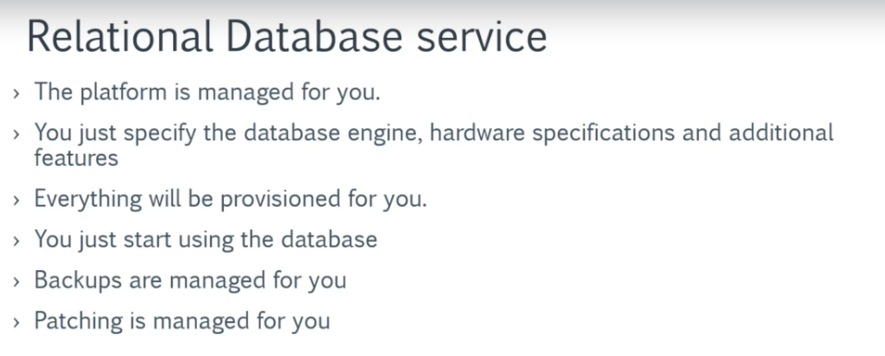

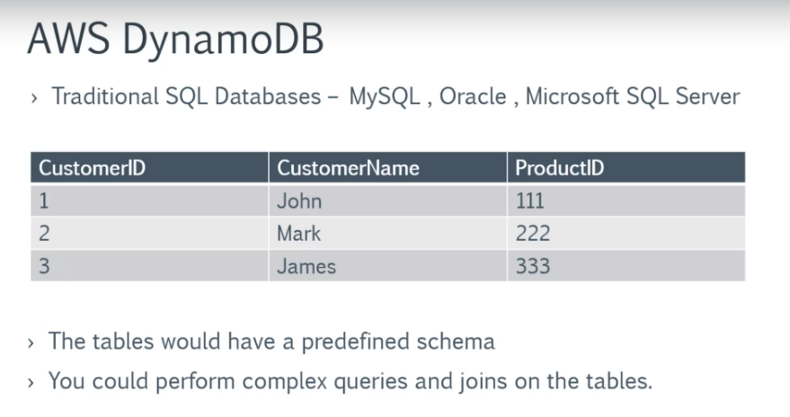

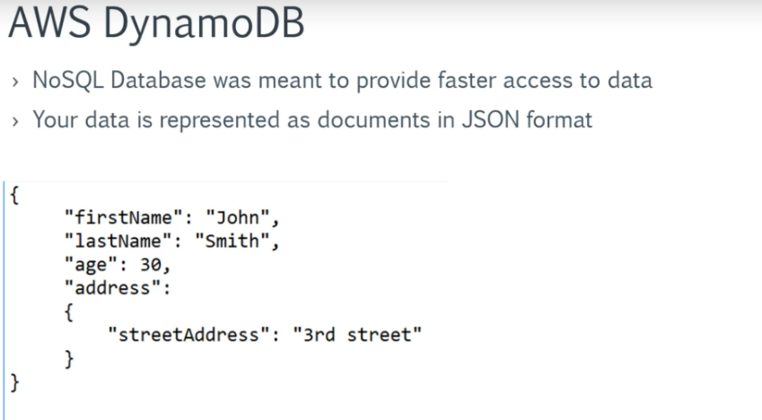

JSON Java Script Object Notation

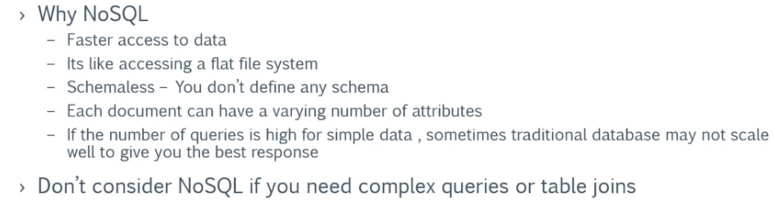

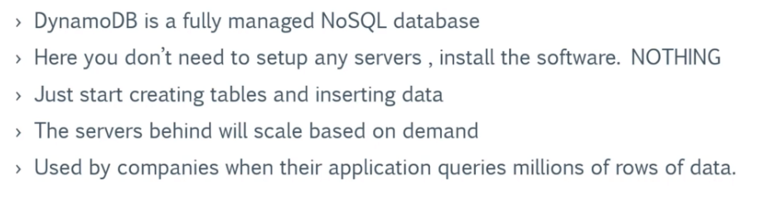

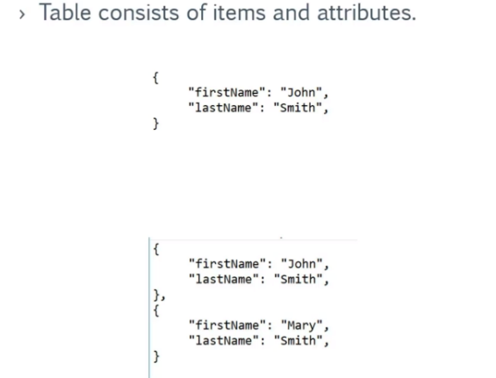

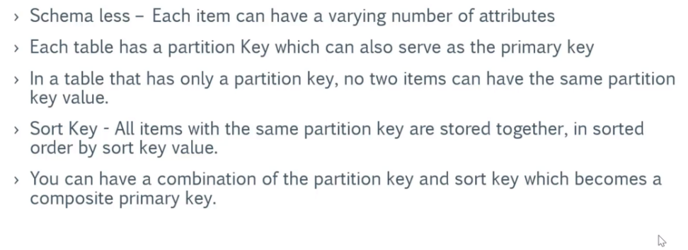



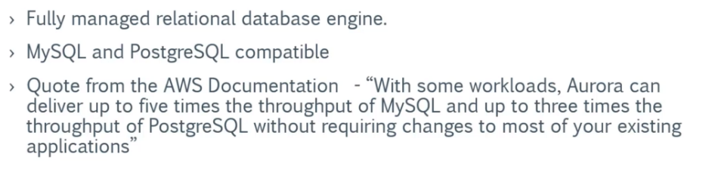

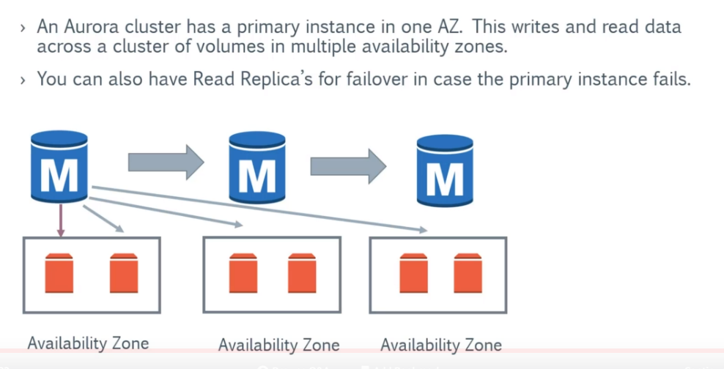



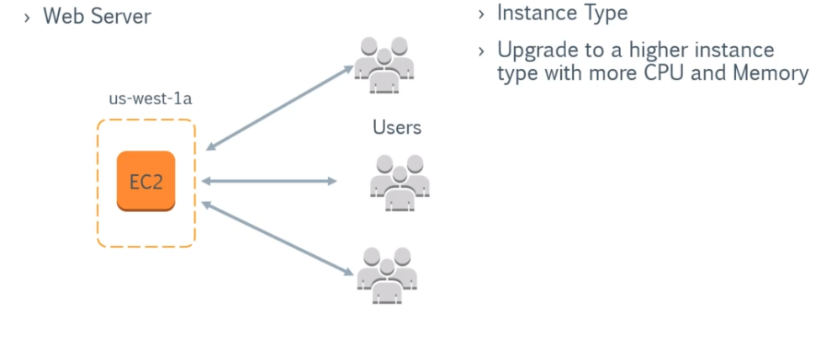

When the number of users increases the ec2 instance may not be able to handle the load and performance issues may rise or your application may crash.

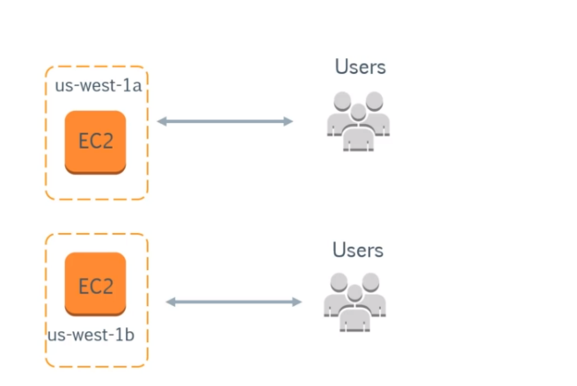

Distributing the load

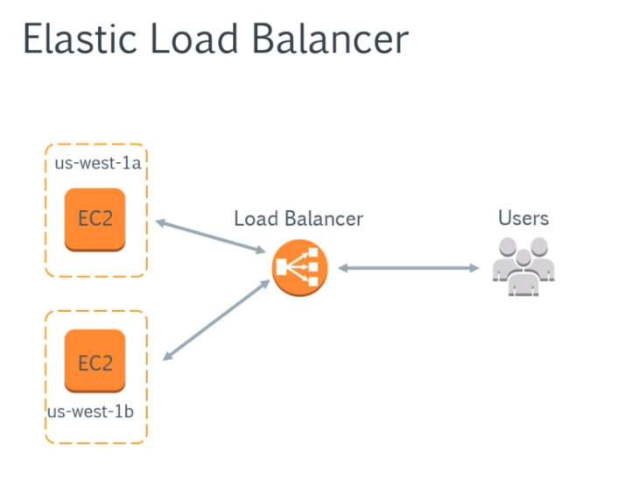

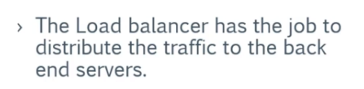

How do we know how much servers to increase?

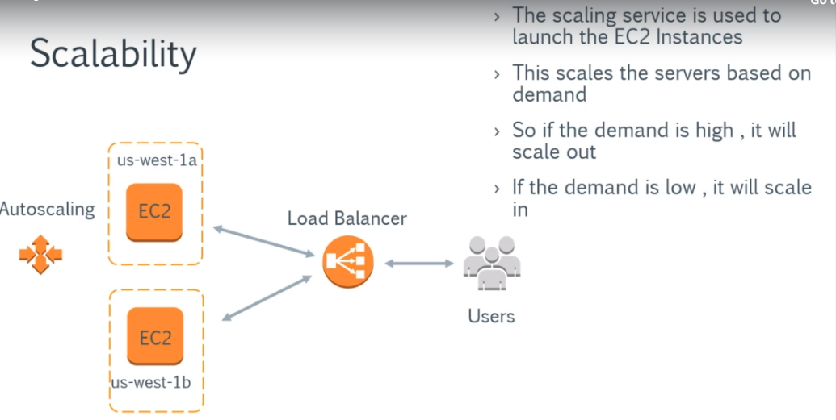

Different types of Load balancers

Classic, Application and Network.

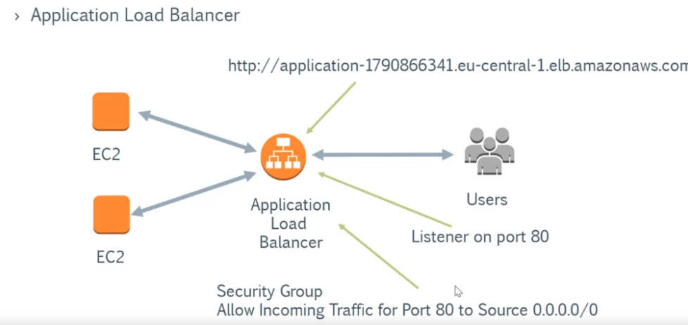

When you create an application load balancer, an domain name(dns) will be automatically created we can use this domain name to access the application load balancer via url.

A listener must be configured to sense the incoming traffic.

Security group for the application load balancer can be configured.

Target Group is the instances to which the traffic must be directed to.

Health check is used to find the health of the ec2 insatances connected to application load balancer are healthy.

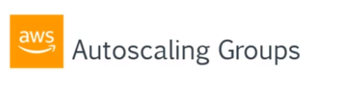

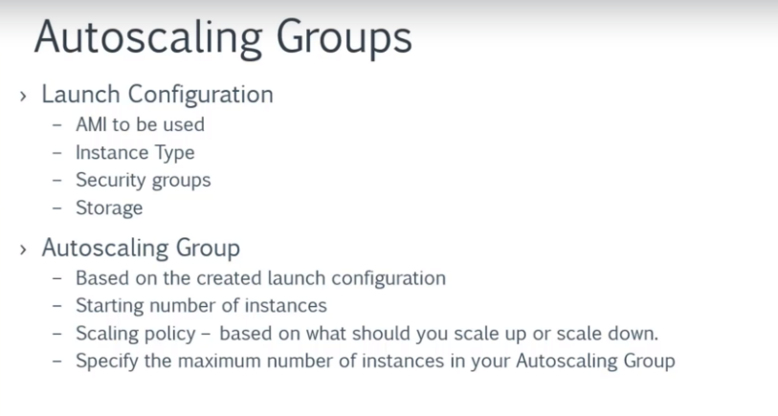

Scheduled Action can be used to autoscale the instances on specific time.



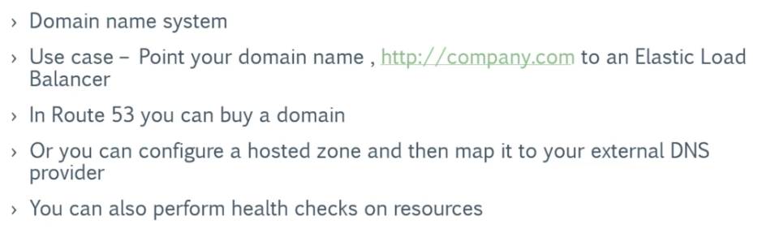

When you want your domain to point to the ip of the instance in which the webapp is hosted..Route 53 can be used.

In type A record:

A Hosted Zone is created with the same name as the domain name and a Resource Record is made to Map the domain name and the ip of the instance where the web app is hosted.

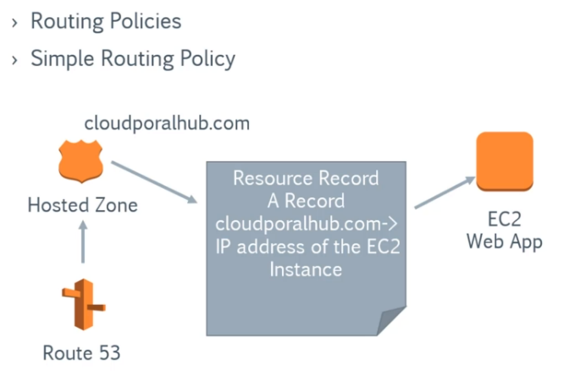

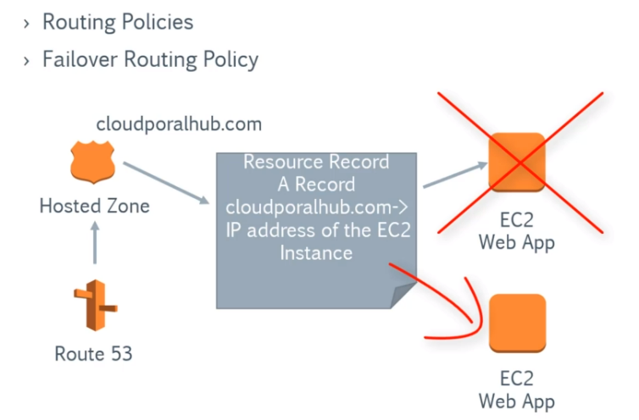

In the Failover Routing policy.. Health checks are made on the ec2 instance where the web app is hosted.When that fails, and a backup for the weapp is hosted on another EC2 instance automatically it points to the healthy EC2 instance.

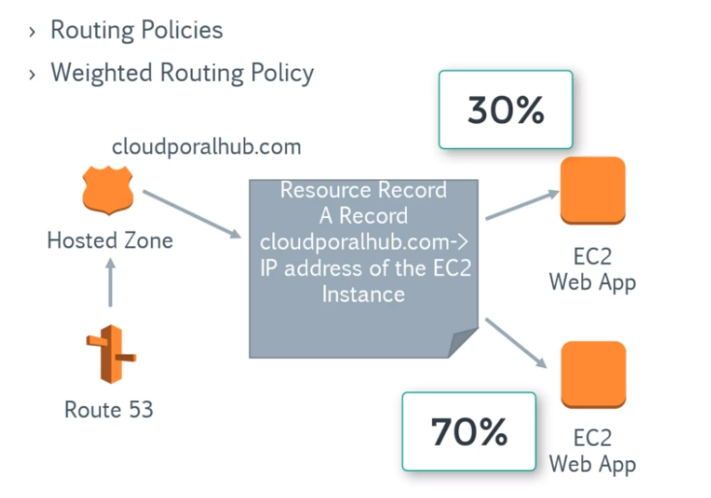

In the Weighted Routing policy, we can actually define the exact percentage of request that must be distributed between the backend servers.

When an hosted zone is created, Two rows are created by default .

First one will have the dns names/ nameservers. That has to be linked to the third party domain provider.

To make that namservers to point to theEC2 instance that we have created.Create a new Record set

Go to the instance and take the public ip address.and use it for the value if using A-IPV4 type.



Consider an instance having an webapp installed is in US and people from all over the world access it.All the people may not get the same experience.To overcome this,

**CDN** can be used. It is an Content Distribution service.

Amazon EC2 F1 is a compute instance with field programmable gate arrays (FPGAs) that you can program to create custom hardware accelerations for your application

X1 Instances are a part of the Amazon EC2 memory-optimized instance family and are designed for running large-scale and in-memory applications in the AWS Cloud.-

Memory Optimized

SAP HANA/Apache Spark

The I2 instance type was designed to host I/O intensive workloads typically generated by relational databases, NoSQL databases, and transactional systems.

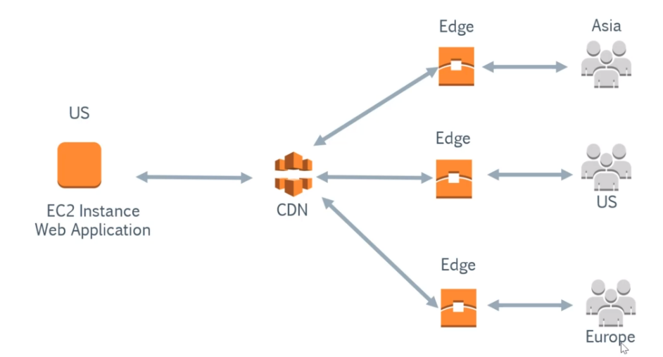

When an CDN is linked to an EC2 instance, When an request is got from an user the CDN delivers the content to the EDGE locations that are near to the user.

EDGE servers also provides CACHING.

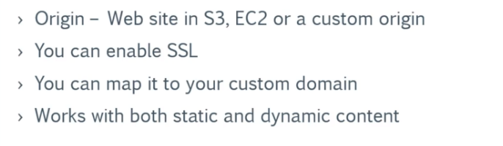



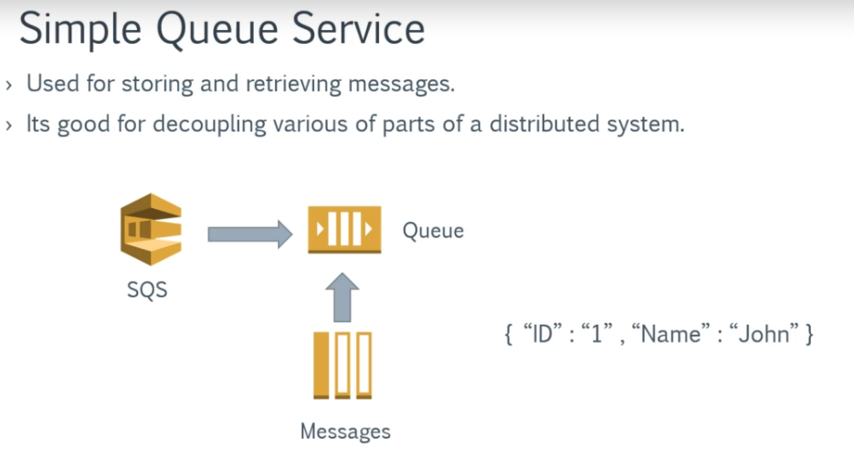

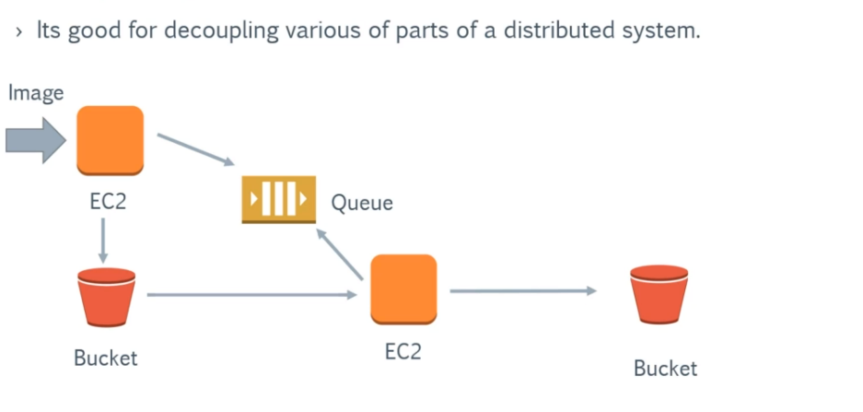

Queue is used when read of instance A and write of instance B are unequal.

If an Queue is not used, if message sent by A is not received by B the message will be lost.

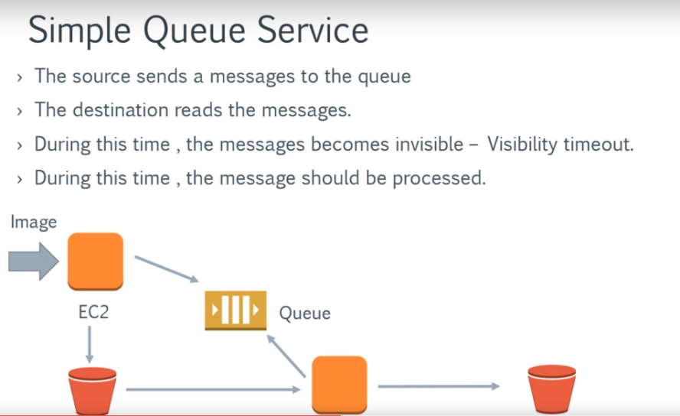

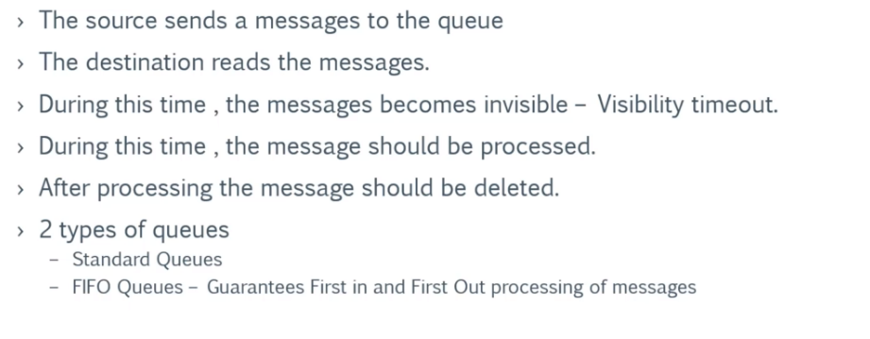



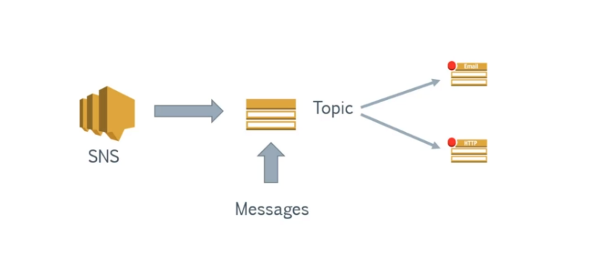

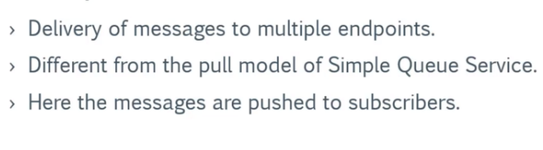

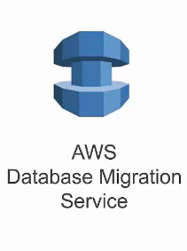

Allows you to migrate database from source to destination. The source and destination can be on cloud or on-premise or a combination of both.

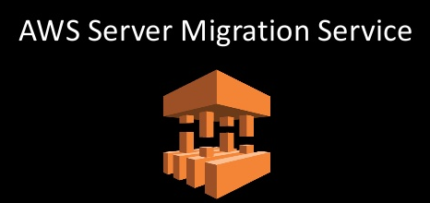

Can be used to migrate existing servers to AWS cloud.

The server volumes are stored as AMI’s.



AWS Marketplace is an online store that helps customers discover, purchase, migrate and immediately start using the software and services they need to build products and run their businesses. ... AWS handles billing and payments, and software charges appear on customers' AWS bill.

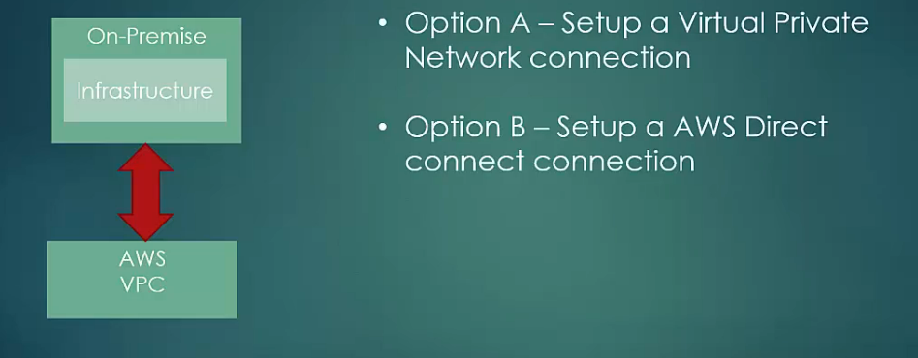

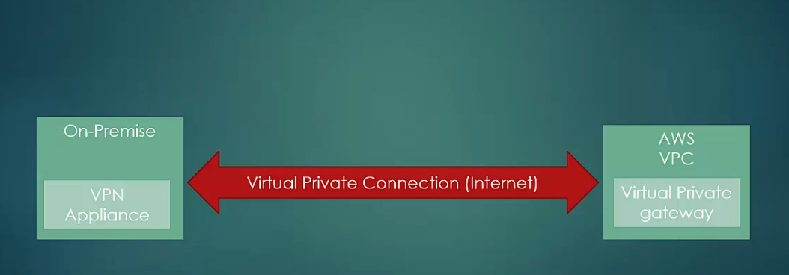

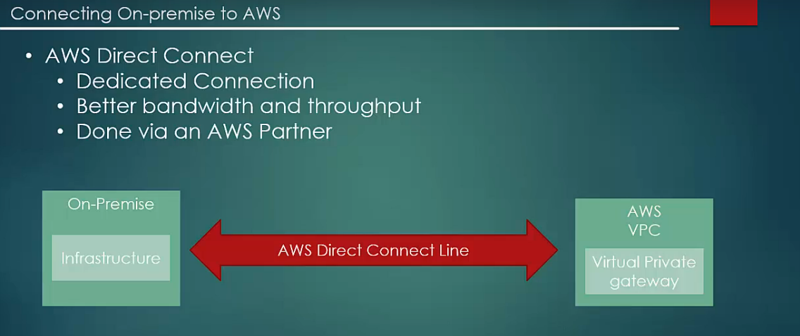



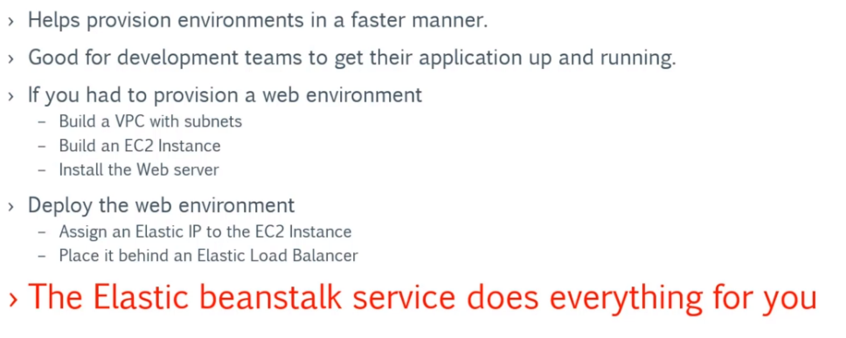

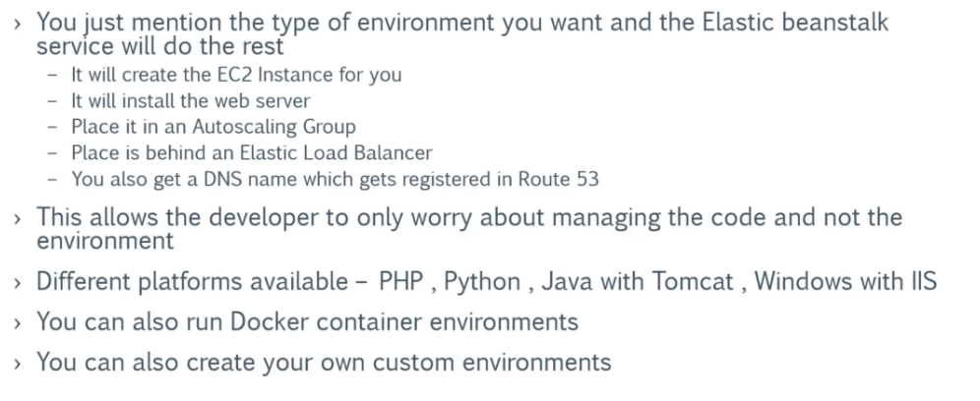

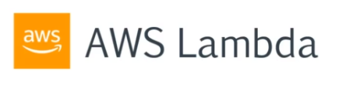

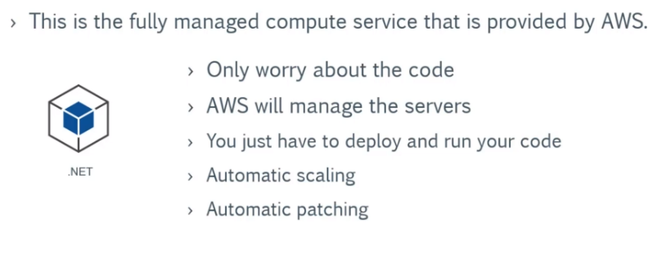

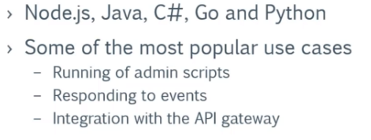



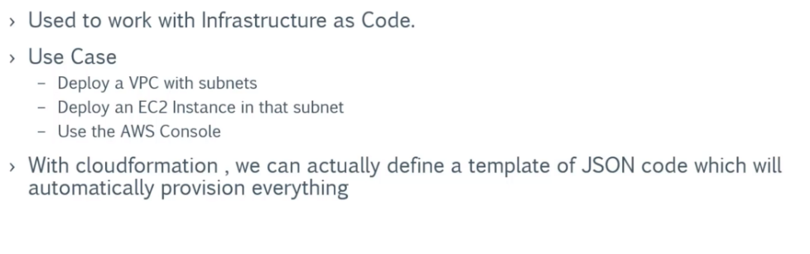

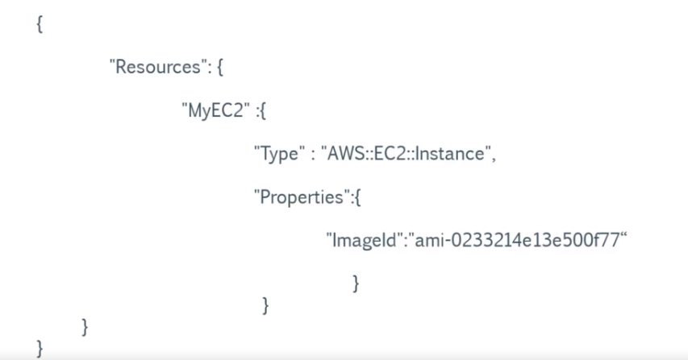



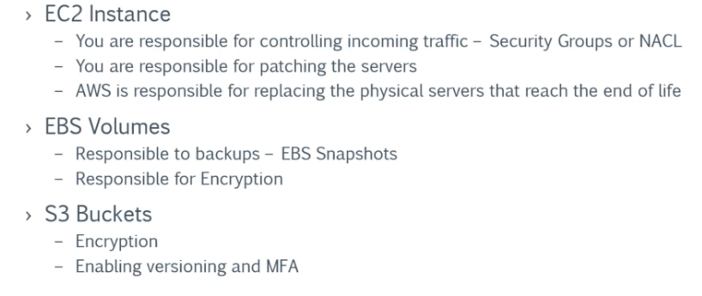

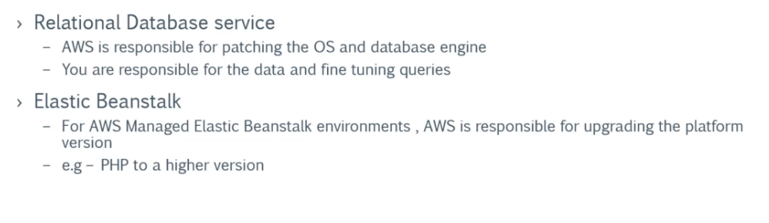

Identity Access Management - IAM

Different users can be created with different privileges to the aws platform.

Command Line Interface.

Is used to access aws resources via a command line interface.



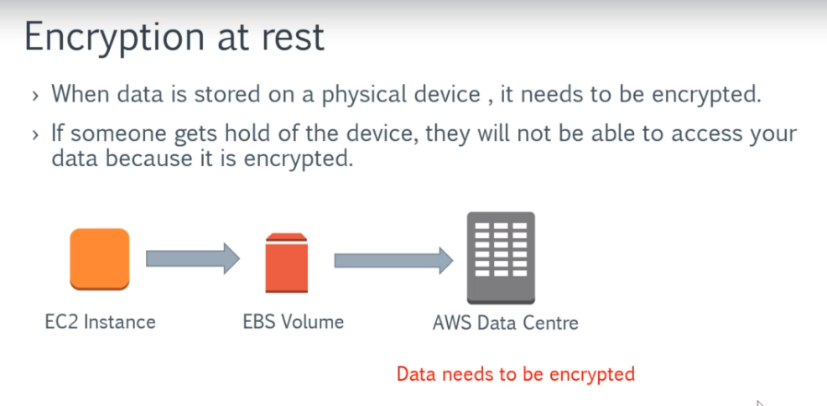

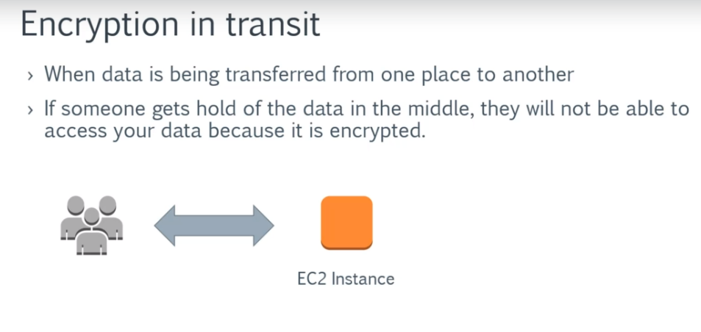



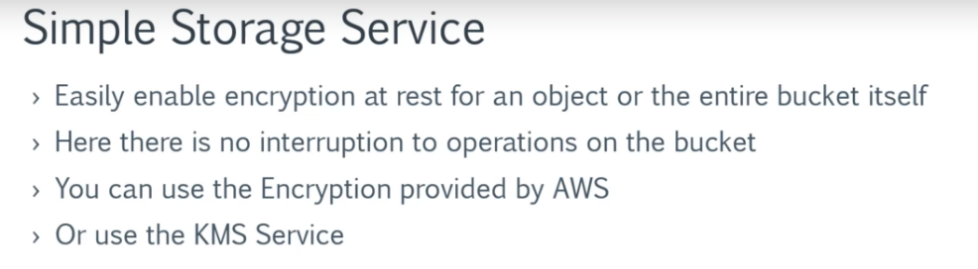

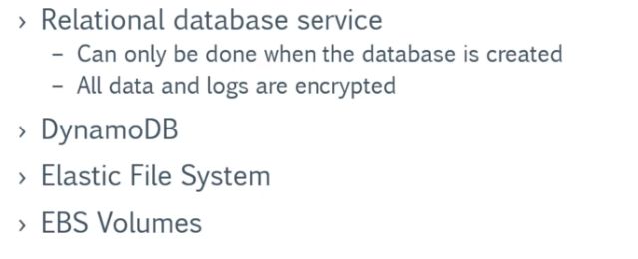



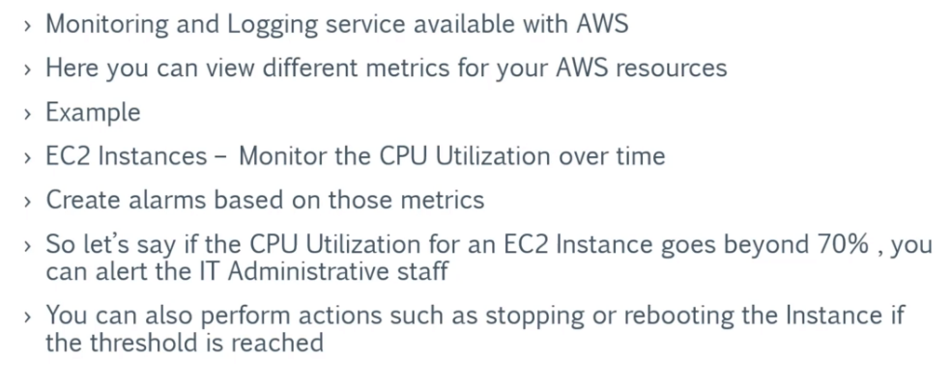

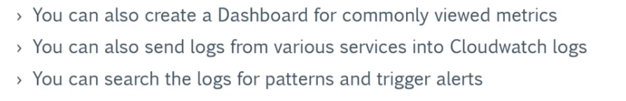



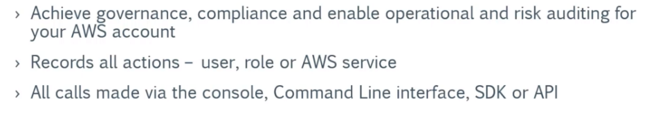

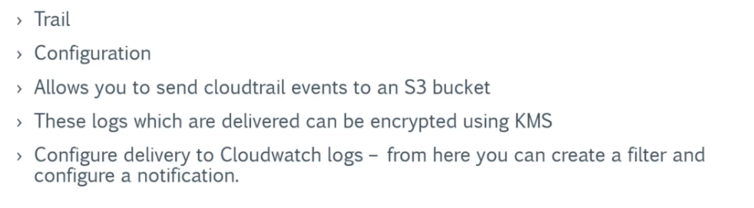

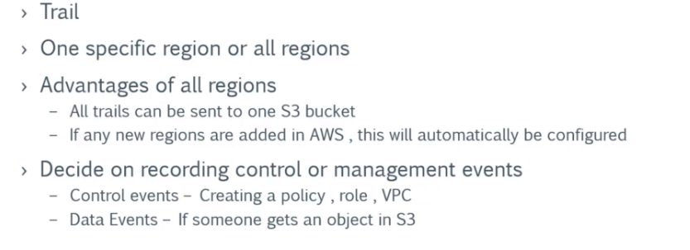



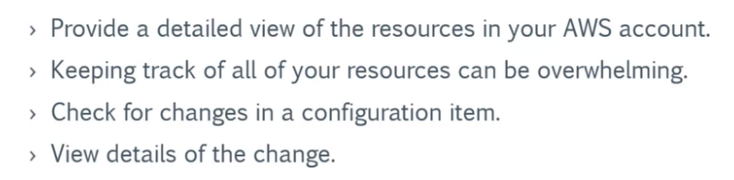



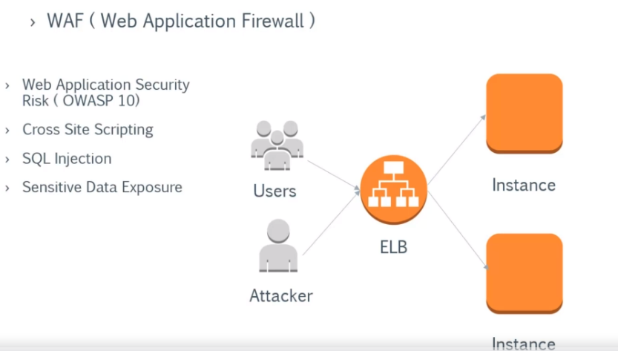

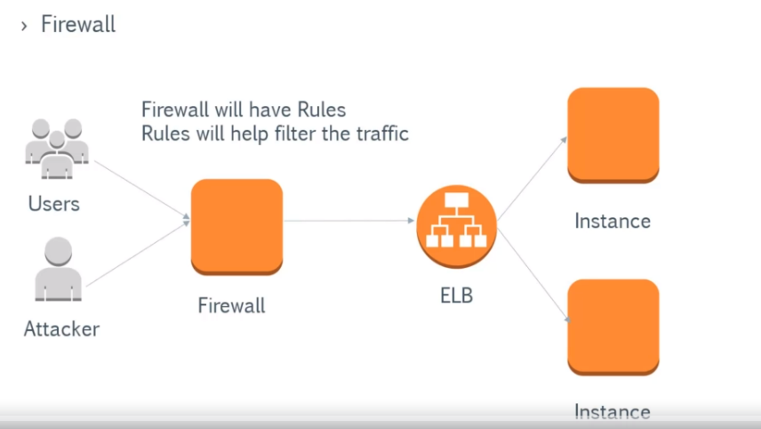

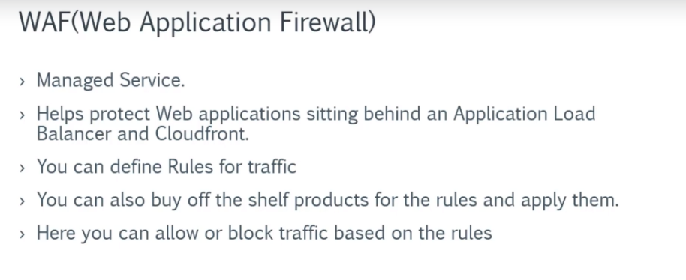



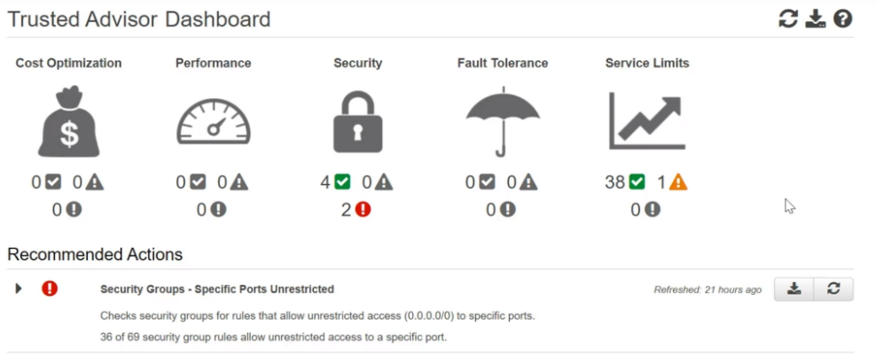

Gives you information on the things that canbe improved in the aws management.



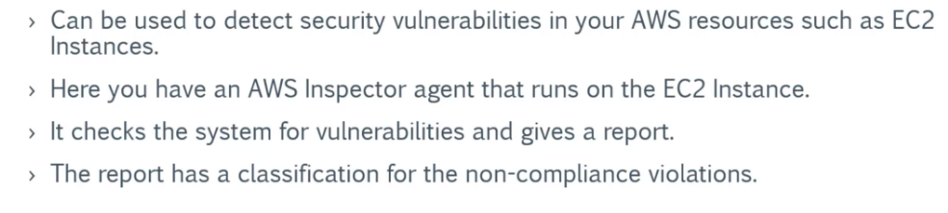

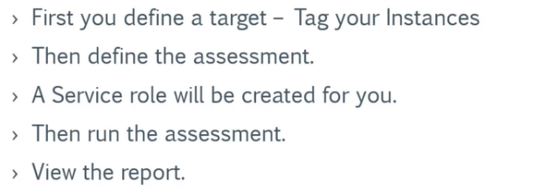

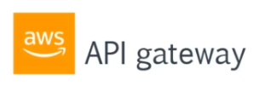

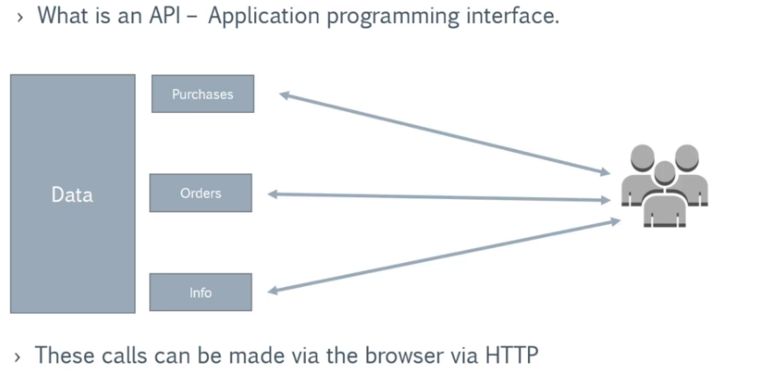

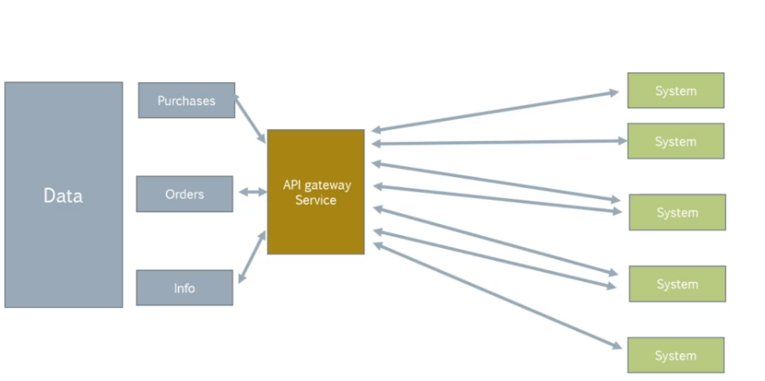

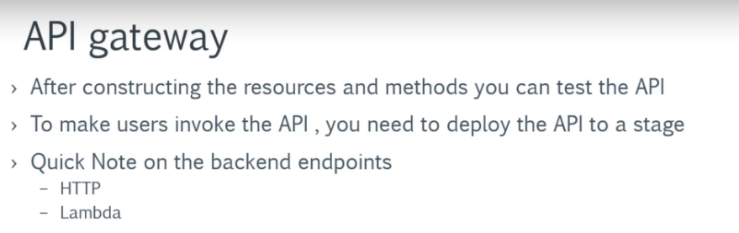



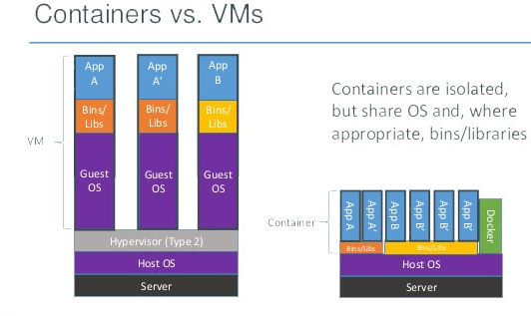

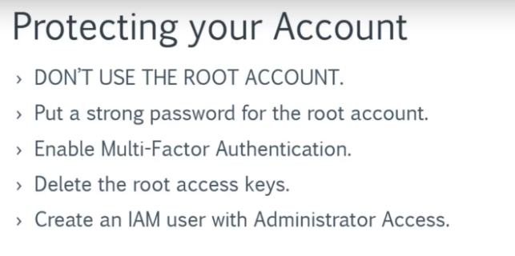

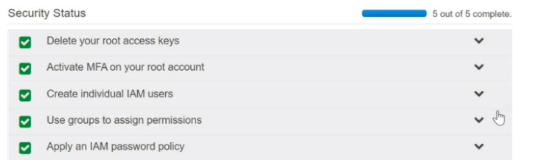



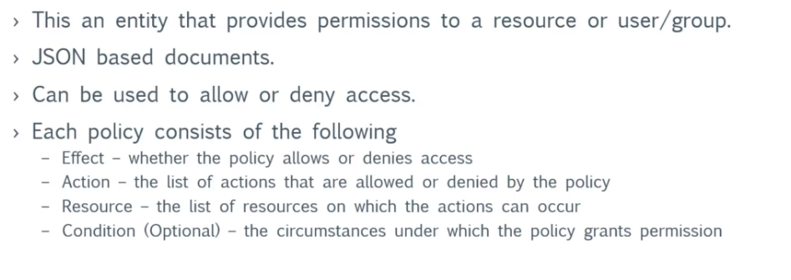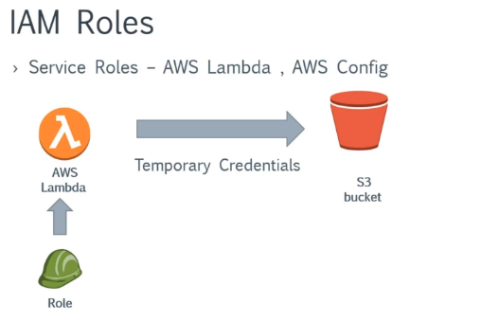

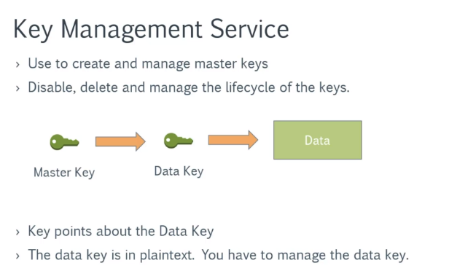

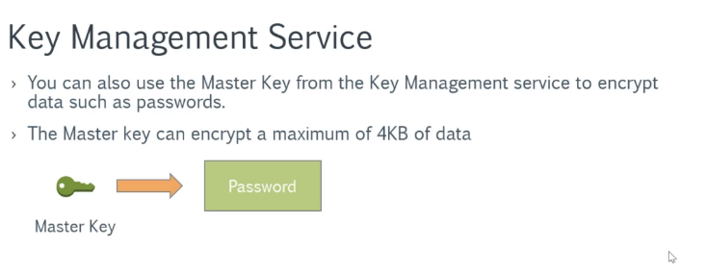



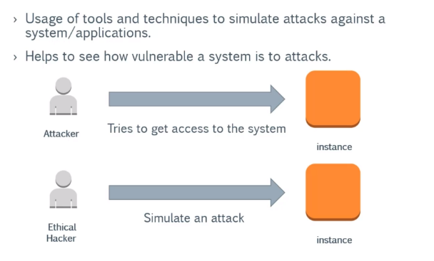

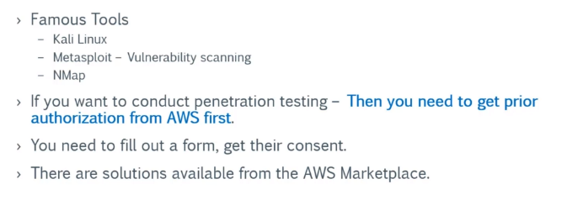



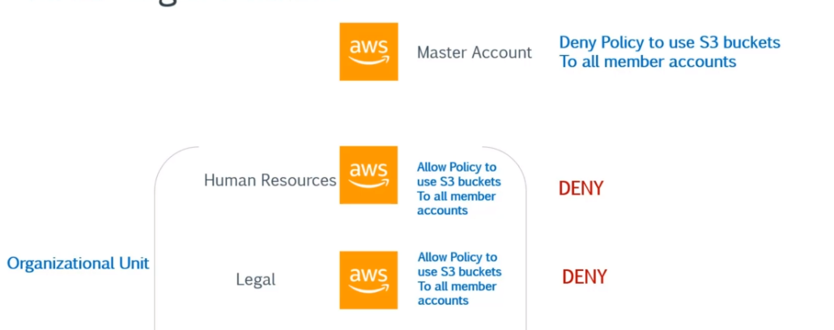

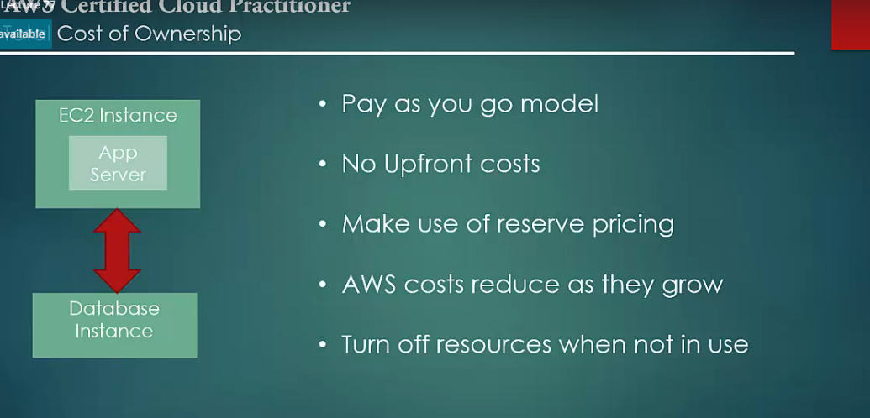



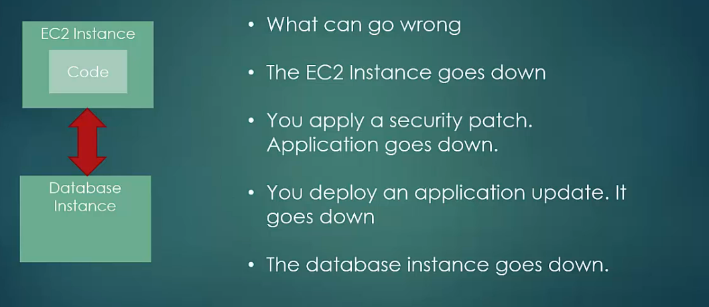

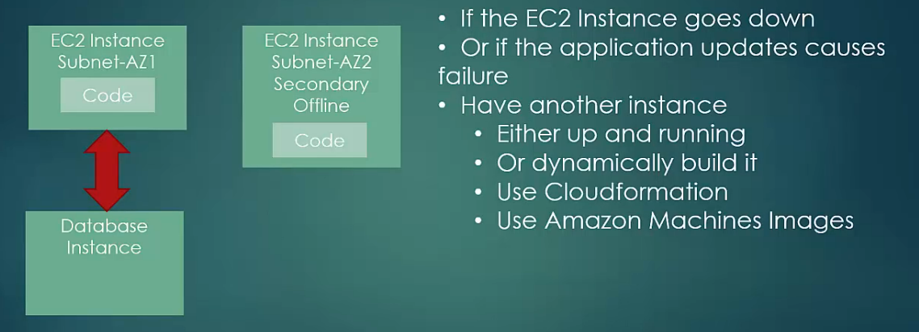

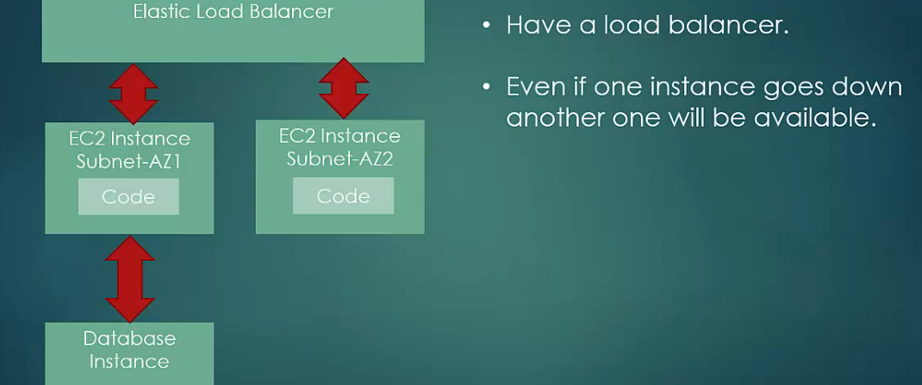

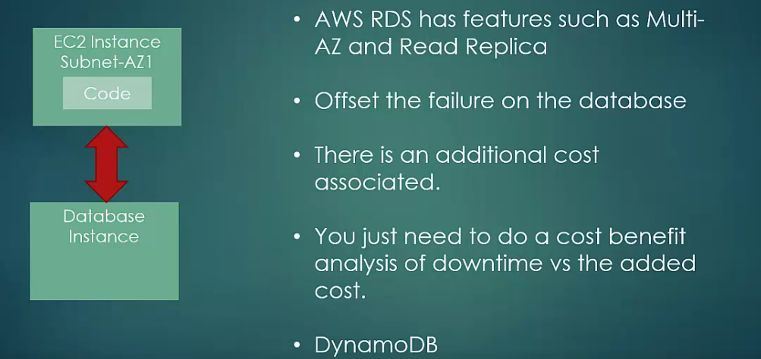

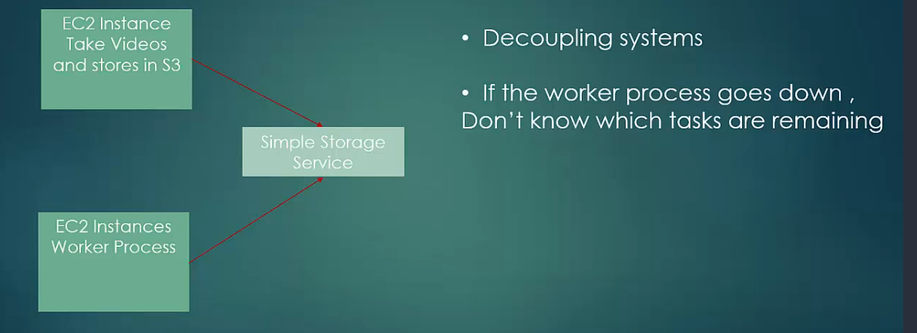

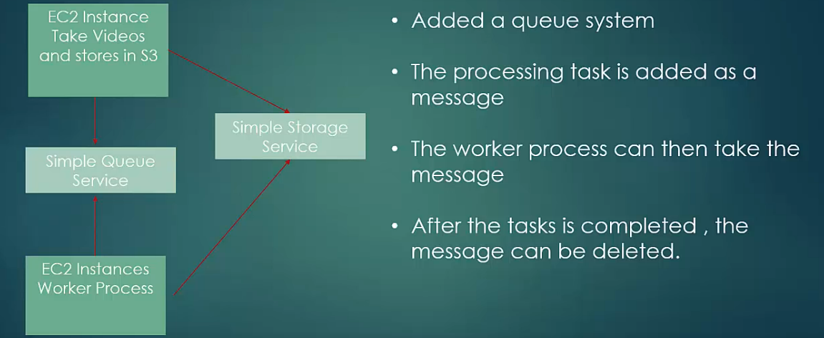



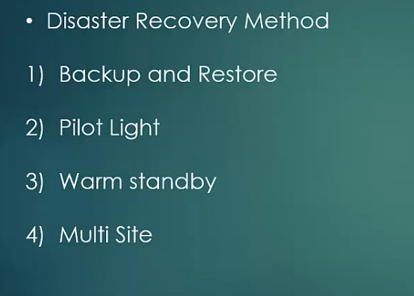

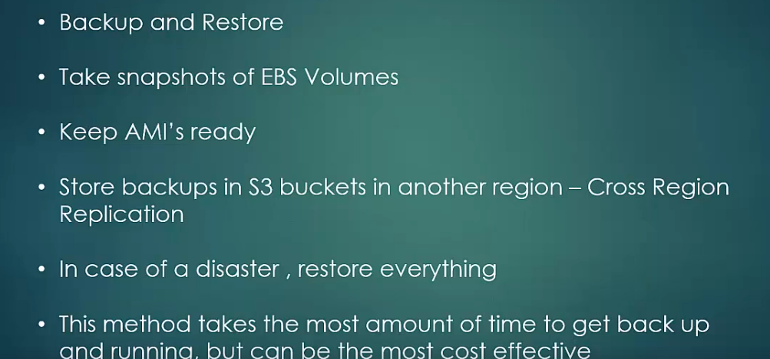

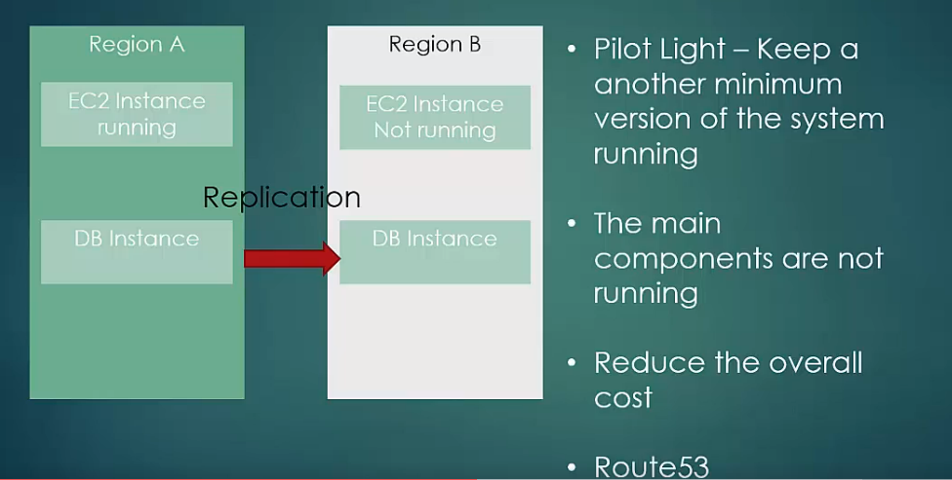

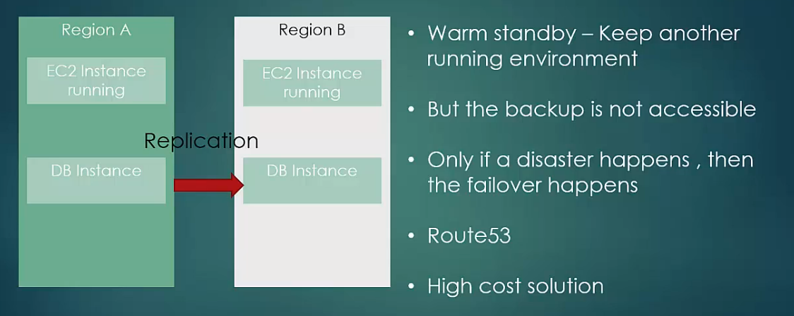

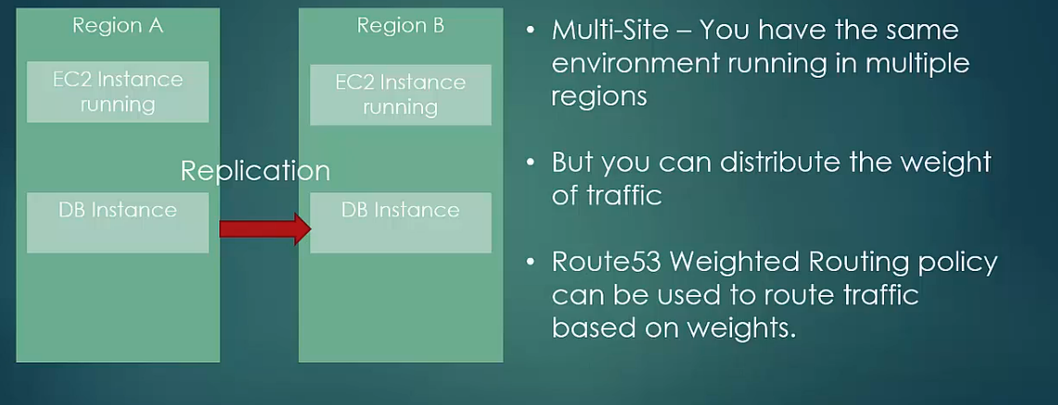

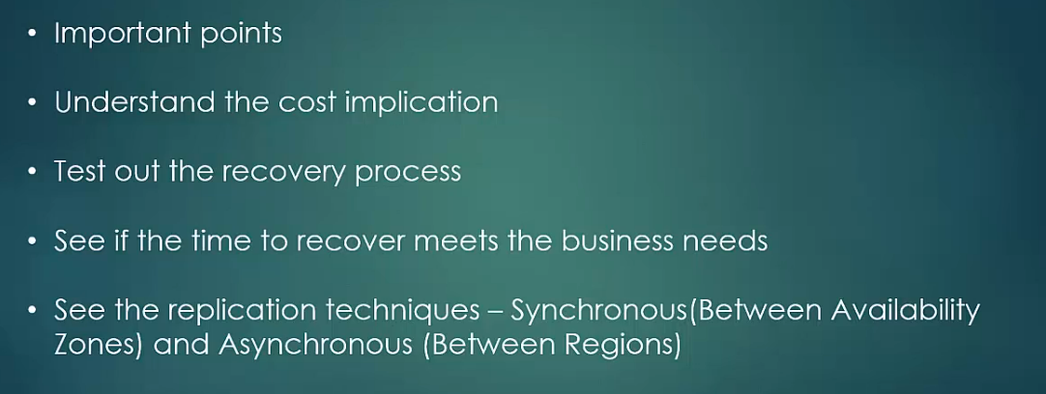



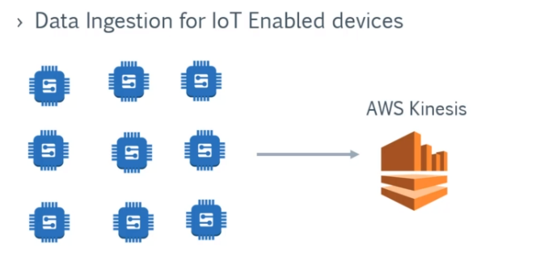

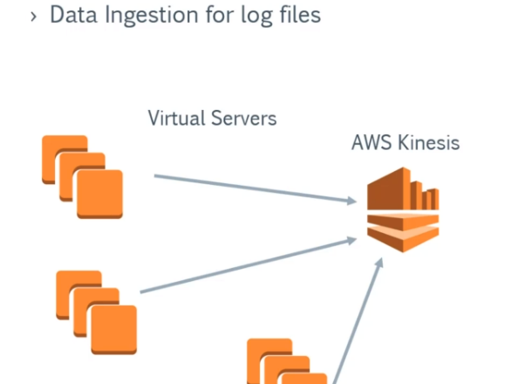

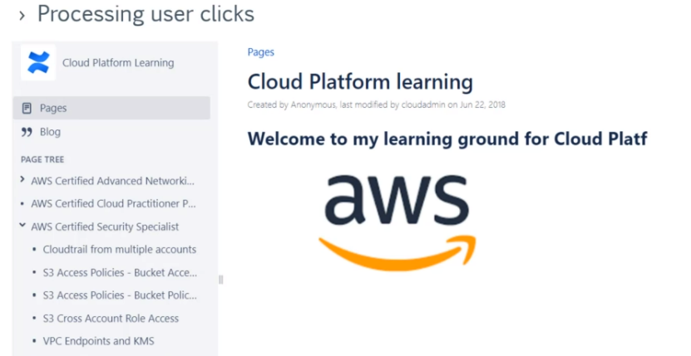

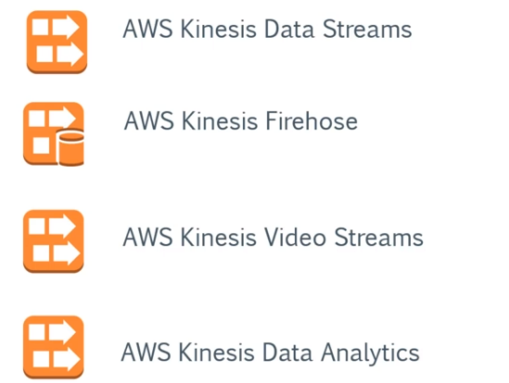

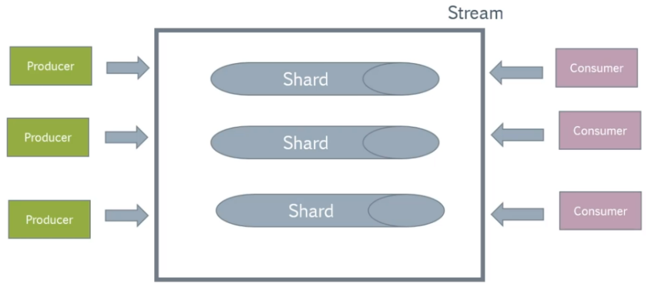

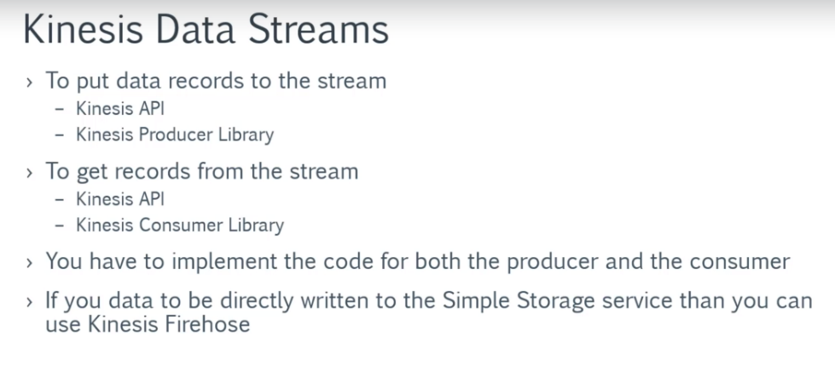

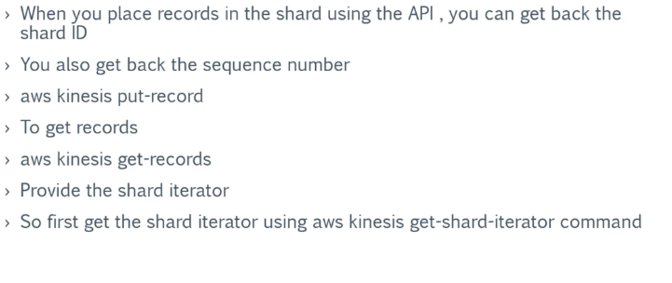



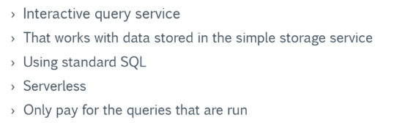

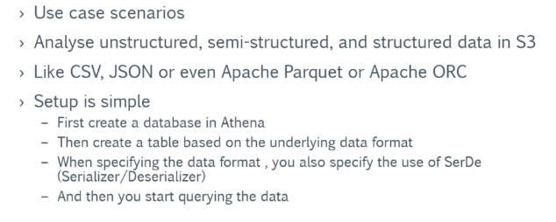



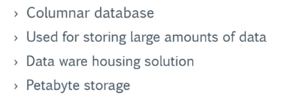

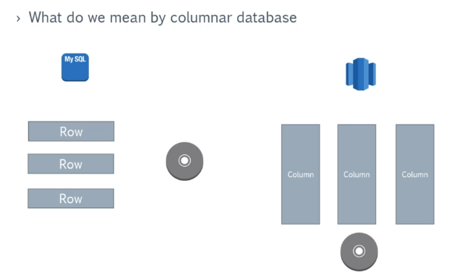

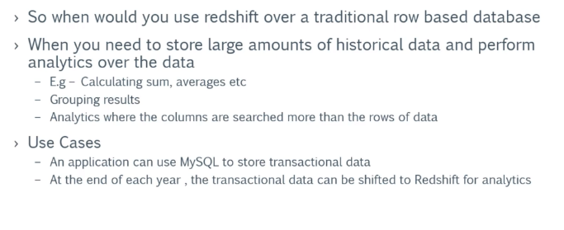

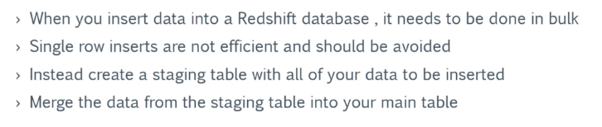



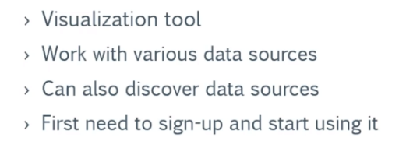

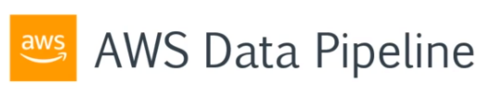

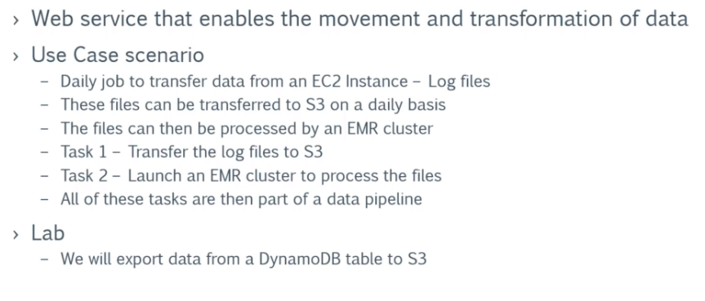

https://apiture-group.slack.com/messages